The Great Pyramid – the way it was built

Background

- Building the Great Pyramid, the last surviving “7 wonders of the world”, was arguably the greatest project undertaken by man.

- The 5000 year mystery can be explained in 5 minutes and is remarkably simple, though not obvious.

- No human would have started such an undertaking without confidence of success. That confidence was a machine mentioned by the historian Herodotus. We now have a working scale model of such a machine.

As today Egypt was hot. Hard work out in the open would have been exhausting and the idea that stone blocks were dragged up slopes to build the pyramid is just not acceptable. Estimates have been made that 100,000 men or more would be required to build the great pyramid but the recent research shows that the local facilities could only support about 20,000 people (including support staff such as cooks) and they would probably have been part time farmers available only during the annual inundation or flooding of the Nile.

The numbers are staggering… The great pyramid is built of some 2.3 million blocks each weighing typically 2½ tons giving a total weight of some 6½ million tons. The pyramid is built as 200 layers of mostly rectangular blocks with a top 145 metres or 480 feet above the base. … So how did they do it?

Wheels would not be invented for another few hundred years. Log rollers and / or hardwood sliders may have been used. Ropes would have been available but do not appear in records we have seen.

So what did they have? Stone, water, desert/sand, timber, peace for many years at a time, substantial manpower and some unusual local geography. It is seems clear that this civilisation of 5000 years ago understood its capabilities well. Maybe the more modern world of wheels, iron and war has distracted us from the basic tenets of life at that time.

Using only materials and knowledge available to the ancient Egyptians we have built a model “machine” of stone and wood that would allow the great pyramid to be built in 10-20 years by 10-20,000 workers, most of whom would have been employed at the quarries. No ruler would embark on a project of such a scale without being pretty confident that it could be achieved – so it might be concluded that the machine was a key element in the decision to build the pyramid in the first place.

The concepts:

A boat floats and goes up and down with the water level, as does a boat in a modern canal lock

a boat can support great weights (equal to the weight of water displaced) so a boat the size of the 46 metre boat the length of the one uncovered in the Giza boat pit, could carry 200-400 tons. Modern ships carry 100,000 tons and more

For a lock to work (and for boats to go up and down repeatedly) there has to be a supply of water to fill the lock and somewhere (at a lower level) for the water to go when emptying the lock.

Imagine a lock near the pyramid, supplied by the Nile in full flood and drained into a desert the other side of the Giza plateau, much of which is below sea level. By operating the lock gates a boat in the lock can be made to rise and fall cyclically.

Let us say the boat in the nearly empty lock with its deck at ground level has a stone block pushed or slid onto it. The boat will float a little lower in the water. When the water level next rises, the boat and stone block also rise.

At his point it is necessary to have a dock-side shelf /platform at the right height next to the boat so the block can be slid onto the shelf before the boat drops down again when the lock is emptied. How can we move the stone up a second time (from its position on the shelf/platform)? Well, if we put a strong table in the boat when the boat is in its lower position, we can slide the block back onto the table in the boat. When the boat again floats upward the block will be lifted a second time and could be slid onto a shelf twice the height of the first shelf. With 10 tables on top of each other of say one metre high and 10 shelves one above the other also a metre apart, it is possible to move the block up 10 metres in height using only the power of water rising in the lock.

I built a 100:1 scale model to show how it can be done.

The model works. It uses a boat a similar size to that discovered in the boat pit next to the great pyramid (46m by 7m, scaled down to 46cm by 7cm. For model dimensions read cm instead of m, gm instead of tonne etc). Stone blocks and tree trunks provide 10 levels of ‘tables and shelves’ each 5 cm apart. It is easily capable of moving 10 blocks at a time (one on each shelf or ‘table’) upwards to a height of 5m If the lock is worked on a six minute cycle, the model will move 10 blocks per hour from the lock level to the top (construction) level. See also paragraphs below

It has become clear the blocks must remain on a pallet or sled all the time they are in transit. This makes it much easier to slide the blocks on and off the shelves. The work is also much easier if the skids are grooved underside and slide on horizontal timber runners (tree trunks again).

If the timber runners are free to move a little and if a small block is placed under the centre of each runner, so it see-saws a few degrees, the runners can be wedged so the sliding of the block/skid is downhill whether sliding it from the shelf or from the ‘table’. As the sliding action is always downhill, it allows a load of say 5 tons to be moved the 2 m on or off the shelves by two or three men with simple levers in a minute or two. This ‘technique’ significant reduces the manpower to make the “lift” work and allows for larger loads to be moved on each sled.

The Figures:

The great pyramid is built mostly of 2-3 ton cubes of limestone with 0.9m sides. Below we use the real world figures rather than the 100:1 scale model figures.

The model works well with up to 8 blocks per sled weighing about 20 tonnes and is capable of an up-down cycle of one minute, delivering 60 loads of 20 tons per hour, or for a 15 hour day:18,000 tons per day. In reality an up and down cycle time of six minutes would be fast, giving 10 loads per hour of 20 tons, or 3000 tons per day. In the case of the 10-shelf working model the 3000 tons are delivered to a height of 50 metres (about 160 feet).

Each shelf/table would need maybe 6 men to lever/slide 20 tons at each stage. With 10 stages this requires 60 men that might work for a 3 or 4 hour shift – a relatively very small part of the workforce. Six men working one sled migh get in each others’ way, so 5 or 10 ton loads requiring 2 or 3 men might have been more practical, after all there is no reason not to have 2 or 3 machines running with smaller loads.

Pyramid first or machine first:

In building the model it became clear that any ‘machine’ with more than a few shelves/tables high resembles a modern lift shaft. This presents some engineering risks in terms of stability and safety of the whole structure. The scale model has the ‘lift shaft’ built over a boat pit next to the pyramid. But as the height of the works and lift shaft gradually increases it is apparent that the support for the growing lift shaft requires all round support, ie a structure of stone block, especially for the higher levels. In other words, the lift shaft requires a pyramid of stone blocks to support it – and the pyramid requires the shaft in the middle to be able to build the pyramid. The two are mutually dependent.

This suggests there must be 1, or more likely several, shafts running vertically through the pyramid and a canal running in at or below ground level for boat deliveries of stone to the base of the ‘lift’. Recent discoveries indicate that barges were used to bring stone blocks from the local quarry as this requires far less effort than other methods.

The shafts and tunnel would be filled in afterwards, but some evidence, especially for the vertical shafts will still be there within the pyramid and should not be too difficult to discover as part of a research project.

The Capstone

The missing cap stone. Constructing the top layers would require stacking extra blocks on the highest layers for filling in the lift exit and for the final filling in of the shaft. The large capstone would not have been cube shaped and would have been awkward to stack and subsequently move into position. Is it possible that whilst moving the capstone into place, it slipped down to the base of the pyramid, and with almost no way to move it back to the top it was perhaps always missing?

The model provides an understanding as to why the pyramids are only found on the West bank of the Nile. There is no obvious drain for the water on the East bank but the West bank land has underground tunnels or channels (refuted by some Egyptologists) that can allow water to flow into the Western Desert. Even if a trench or tunnel had to be dug through the Giza plateau this would be worthwhile to allow the use of the ‘machine’.

Other aspects

The Nile is the most obvious water source but the very large Lake Qarun overflows down waddis towards Giza and could be diverted (maybe via man made canal) to the pyramid sites, after all the volume of water needed is not very great.

How did the idea arise? It would have been common knowledge that boats can carry and ‘lift’ big loads as the Nile was not only the motorway of the day, it was almost the only transport route for anything heavy.
Before the various Aswan dams were built from the 19th century, the Nile flooded every year and provided irrigation for crops for some miles each side of the normal riverbank. At one time I suggest the flooding waters found a route into the Western Desert possibly via underground channels through the limestone plateau, typical of limestone hills across the globe. Damming a river or canal would be natural in order to maximise the local irrigation thus forming a simple lock. Once the idea was established a simple one or two stage lift system may have been employed for various rock-lifting jobs.

A key motivation for the pyramids might well have been the unused manpower available during the annual flooding season. Keeping men busy and maintaining control over the nation might also have been a factor.

Herodotus

The renowned historian wrote his history of Egypt some 300-500 years after the temples were built (and more than 2000 years later than the pyramids) and states the pyramids were build using a wooden machine and that it was built from the top down!

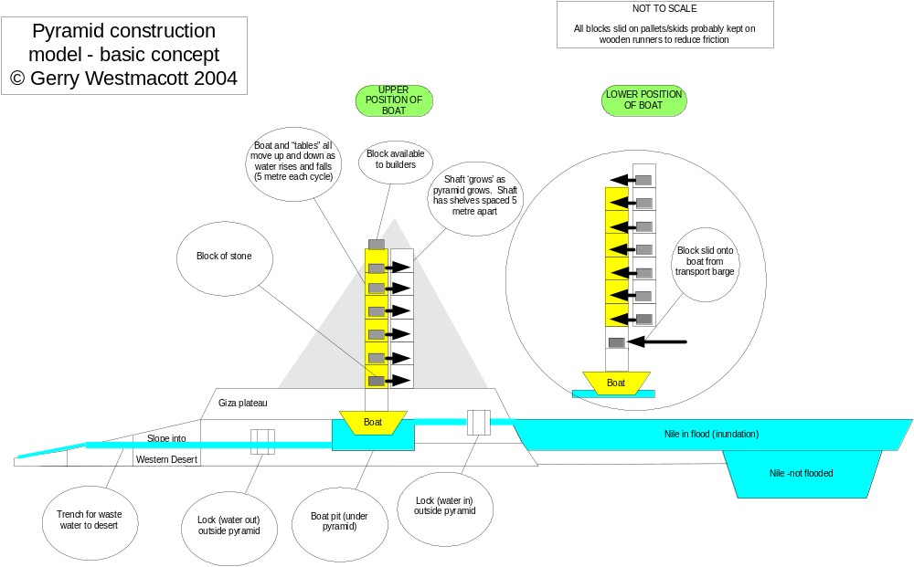

the 100:scale model picture:

